Name: _______________________ ID: _______________________

**Analytical Chemistry II – Quiz (16th March, 2021)**

1) How does $v_{o}$ relate to $V_{i}$ in this circuit? Write down the formula.

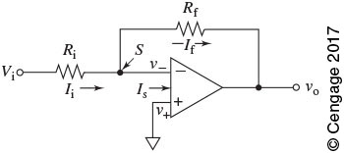

2) List four main sources of instrumental noise in analytical measurements.

thermal noise

shot noise

flicker (1/f) noise

environmental noise